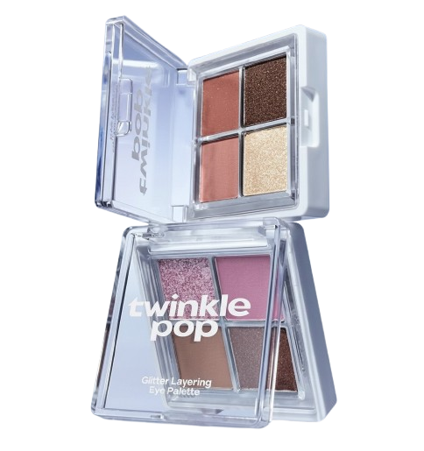
Name : Twinkle pop
Description : Twinkle Pop eye shadow palette is a Korean makeup palette with soft, pretty colors. It usually has light, medium, and shimmer shades that are easy to blend. The colors give a natural, fresh, and glowing look, perfect for daily and party makeup.
How to use :
Use a brush or your finger to apply matte shade over your eyelid.
Apply the shimmer shade to your lid and lower lash line for a touch of sparkle.
Use the glitter shade to high light the center of your lid or corner of your eyes.
Blend well for a smooth and soft finish.

